 

Cairo University

Faculty of Computers and Information Department of Computer Science

Fci E-Campus

The Way to Better Education

**Academic Year 2017-2018**

**Final Year Documentation of Graduation Project**

 

Cairo University

Faculty of Computers and Information Department of Computer Science

**Supervised by**

***Dr. Mohammed Nassef***

***TA. Nora Abdel Hamid***

Implemented by

|  |  |
| --- | --- |
| ***20140169*** | ***Abdul-Aziz Mahmoud Abdul-Aziz*** |
| ***20140163*** | ***Abdurrahman Mahmoud Mohamed*** |
| ***20140197*** | ***Amr Madge Mohamed Ezzat*** |
| ***20140030*** | ***Ahmed Abdel Mohsen Ahmed*** |
| ***20140170*** | ***Abdallah Abdelazim Abdallah*** |

**Academic Year 2017-2018**

**Final Year Documentation of Graduation Project**

Contents

**Introduction** 4

Abstract 4

introduction to the main area of the project 4

Motivation 4

Problem definition 4

Project Objective 4

Gantt chart of project time plan 4

Project development methodology 4

The used tools in the project 4

Report Organization 4

**Related work** 4

**System Analysis** 4

Project specification 4

Functional requirement 4

Non-functional requirement 4

Use case Diagrams 4

Use Case Tables 5

System test cases 5

System Design 5

System Component Diagram 5

System Class Diagrams, 5

Sequence Diagrams 5

Project ERD 5

System GUI Design 5

Implementation and Testing 5

# **Introduction**

## Abstract

## introduction to the main area of the project

software concepts

Motivation

## Problem definition

Project Objective

## Gantt chart of project time plan

Project development methodology

The used tools in the project

## Report Organization

# **Related work**

# **System Analysis**

## Project specification

Functional requirement

Non-functional requirement

Use case Diagrams

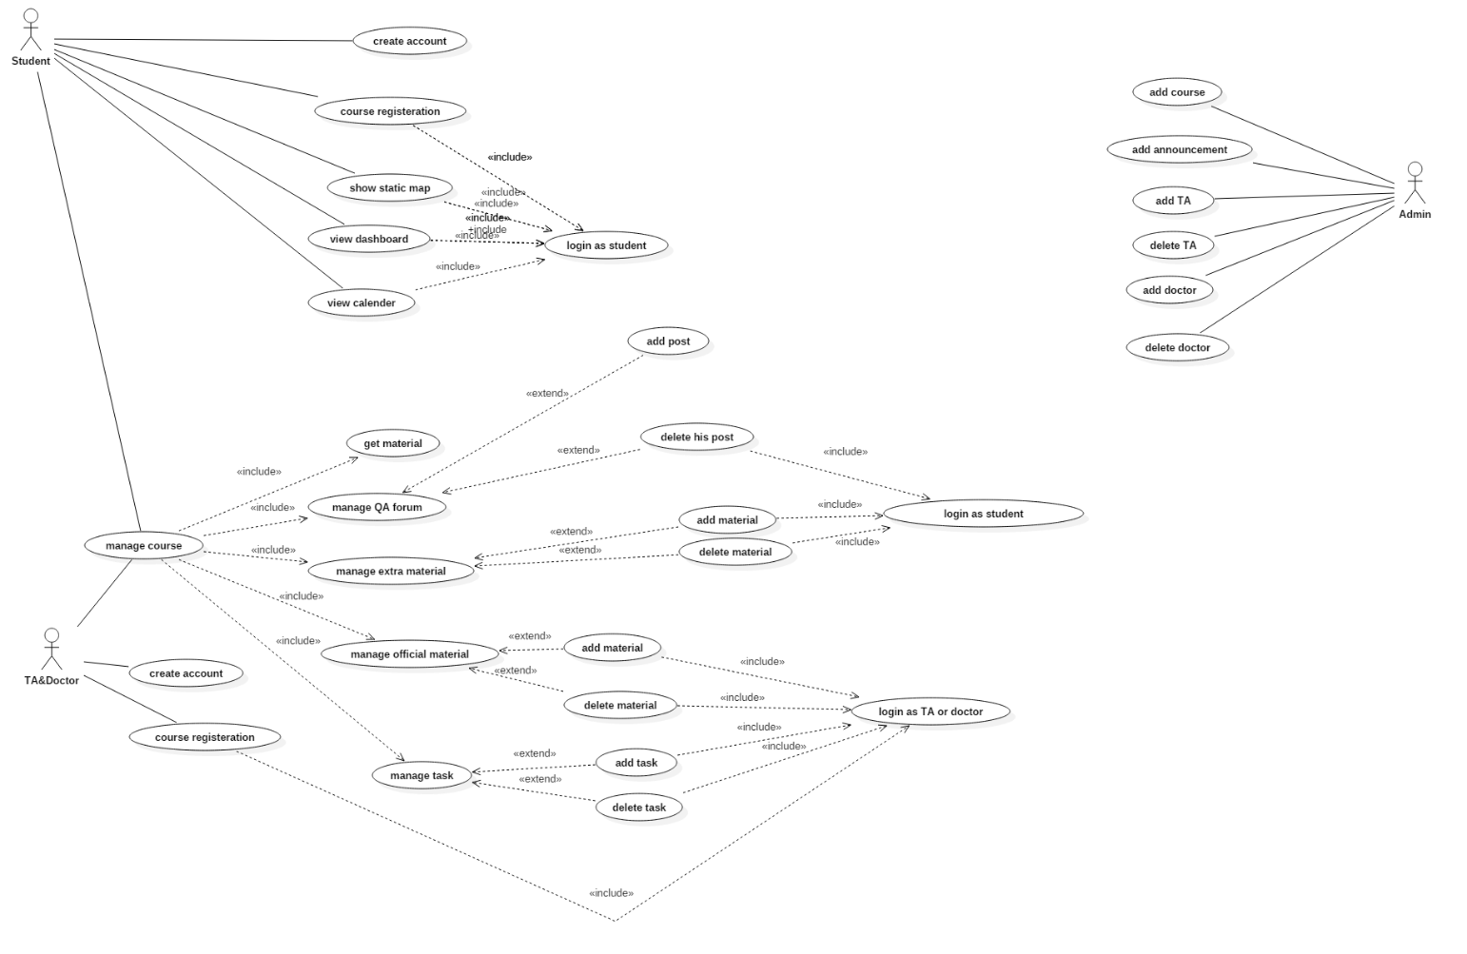

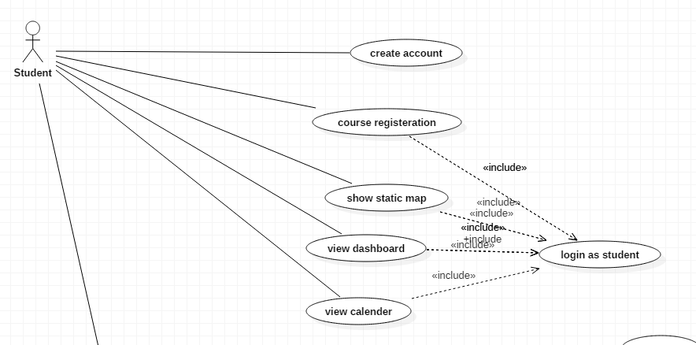

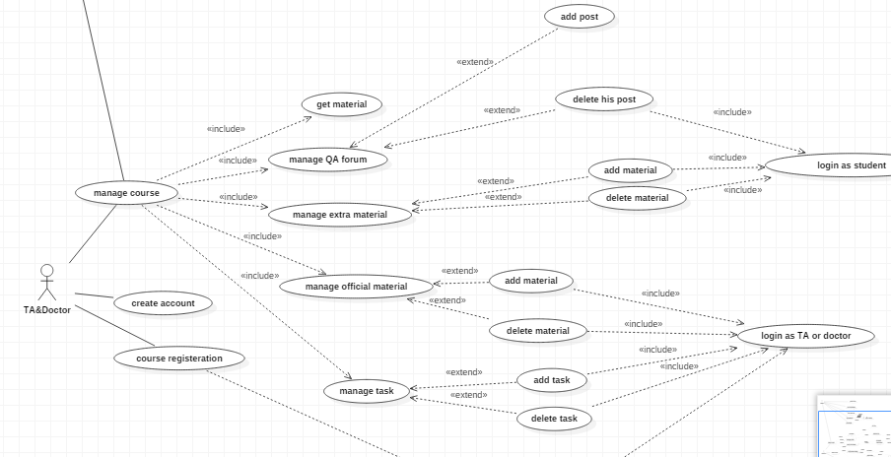

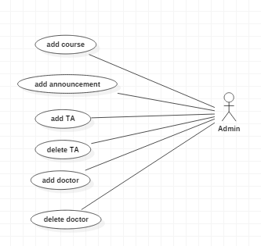

## Use Case Tables

|  |  |  |
| --- | --- | --- |
| Use Case ID: | 1 | |
| Use Case Name: | Login | |
| Actors: | TA/Doctor – Student – Moderator student | |
| Pre-conditions: | User register in the app and validate his account | |
| Post-conditions: | ______________________ | |
| Flow of events: | **User Action** | **System Action** |
| * User Selects to login |  |
|  | * System returns Login page |
| * User enters his username * User enters his password |  |
|  | * System Verifies his information * System logs him in to his account |
| Exceptions: | **User Action** | **System Action** |
| * User Enter username and Password |  |
|  | * username does not exist or password is wrong * System rejects the Login * System demands the user to enter correct username and password |
| Includes: |  | |
| Notes and Issues: | Login will identify if the account corresponds to TA/Doctor, Student or Moderator student. | |

|  |  |  |
| --- | --- | --- |
| Use Case ID: | 2 | |
| Use Case Name: | TA/Doctor register | |
| Actors: | TA/Doctor | |
| Pre-conditions: | TA/Doctor has a valid academic E-mail | |
| Post-conditions: | TA/Doctor validate his account from the mail sent to his academic mail | |
| Flow of events: | **User Action** | **System Action** |
| * TA/Doctor select to register |  |
|  | * System returns registration page |
| * Enter the required information |  |
|  | * System check that neither of his data violate the specifications * System sent a verification code to the entered academic mail |
| * TA/Doctor enters the verification code |  |
|  | * System match the verification code * creates the account |
| Exceptions: | **User Action** | **System Action** |
| * TA/Doctor entered data that violate the specifications |  |
|  | * System recognize that the entered data violate the specifications * System demand the TA/Doctor to enter his data again in right manner. |
| Notes and Issues: | If TA/Doctor enter invalid E-mail he will not be able to validate his account so he will not be able to complete registration. | |

|  |  |  |
| --- | --- | --- |
| Use Case ID: | 3 | |
| Use Case Name: | Course registration | |
| Actors: | Student | |
| Pre-conditions: | Login | |
| Post-conditions: | ____________________ | |
| Flow of events: | **User Action** | **System Action** |
| * Student Show courses |  |
|  | * System return List of courses |
| * Student select a specific course |  |
|  | * System return course information and some choices |
| * Student Select register in this course |  |
|  | * System return a box to write course code |
| * Student enter course code |  |
|  | * System check that the course code is right * System add this course to Student courses |
| Exceptions: | **User Action** | **System Action** |
| * Student entered invalid course code |  |
|  | * System demand to enter course code again |
| Includes: |  | |
| Notes and Issues: | You should have the course code to register in the course | |

|  |  |  |
| --- | --- | --- |
| Use Case ID: | 4 | |
| Use Case Name: | Add Material | |
| Actors: | TA/Doctor – Moderator student | |
| Pre-conditions: | Login – Assign to this course | |
| Post-conditions: | ____________________ | |
| Flow of events: | **User Action** | **System Action** |
| * User shows the courses he assigned to |  |
|  | * System return List of courses |
| * User select the course he wanted |  |
|  | * System return course information and some choices |
| * User select add material |  |
|  | * System return a box to upload material |
| * User upload material |  |
|  | * System assign the uploaded material to the course * System send notification to the students assigned to this course |
| Exceptions: | **User Action** | **System Action** |
|  |  |
|  |  |
| Includes: |  | |
| Notes and Issues: | If you are student the add material button will not appear to you | |

System test cases

# System Design

## System Component Diagram

## System Class Diagrams,

Sequence Diagrams

## Project ERD

## System GUI Design

# Implementation and Testing